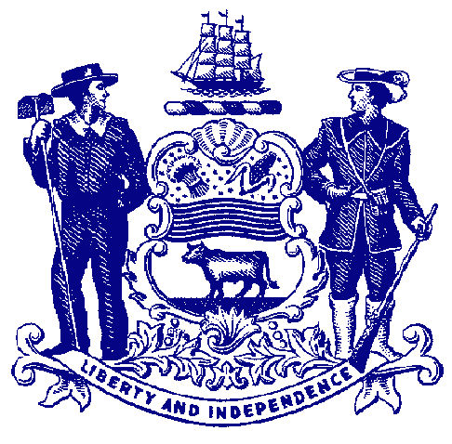

Delaware House of Representatives
Rep. Franklin Cooke

For Immediate Release:
May 19, 2022

House Passes Cooke Bill to Prohibit Cashless Stores

HB 299 would require many retail businesses to accept cash payments for goods and services

DOVER – The House passed a measure Thursday that would protect thousands of residents who primarily use cash to purchase goods and services.

As technology grows and evolves, society has been moving more toward a cashless system. While that development has many benefits, it can present a very serious challenge for residents to be able to obtain necessities.

In Delaware, approximately 20% of residents are unbanked or underbanked, meaning that they do not have sufficient access to mainstream financial services typically offered by retail banks. These residents – primarily young people, homeless, are low-income residents – rely on paying with cash to purchase food, medicine or other goods.

Sponsored by Rep. Franklin Cooke, House Bill 299 would prohibit the seller of consumer goods or services from refusing to accept cash payment at a retail store through an in-person transaction, except in limited circumstances. It would create graduated civil penalties for violations and provides consumers a private right of action to recover double damages.

“Not everyone has a credit or debit card. Teenagers, low-income residents and homeless Delawareans are among those who don’t use electronic forms of payment. Cashless stores can have a discriminatory effect on those thousands of residents who use cash to purchase the basic necessities of life,” said Rep. Cooke, D-New Castle.

“There’s also a decent chance a person who doesn’t have a credit card doesn’t have a vehicle, meaning if their local store doesn’t accept cash payments, they are left without easy access to the goods they need, piling on more. We need to have an inclusive market that allows everyone to be able to purchase goods they and their families need. This bill requires that businesses continue to accept cash as payment and not charge customers more for using cash.”

HB 299 would not apply to sales of goods or services by electric or gas utilities, telephone, mail or internet sales, or for services provided at parking lots or garages. It also would exempt transactions for the rental of consumer goods, services, or accommodations for which posting collateral or security is typically required, or transactions at any sporting or entertainment event, including music festivals.

“In the next few years, we are going to see a slew of incredibly exciting innovations and changes to the status quo,” said Sen. Jack Walsh, the Senate prime sponsor of HB 299. “But embracing these changes must not come at the cost of leaving out working-class Delawareans. It can be easy to forget that over 8 million U.S. households do not have bank accounts and that many people cannot obtain credit or debit cards. For them, cashless stores make navigating an increasingly unequal economy that much harder. I want to thank Rep. Cooke for advancing this legislation and I look forward to passing HB 299 when we return to session in June.”

Massachusetts, New Jersey and Rhode Island and cities such as Philadelphia and New York City have already banned cashless stores.

HB 299 heads to the Senate for consideration.

###

