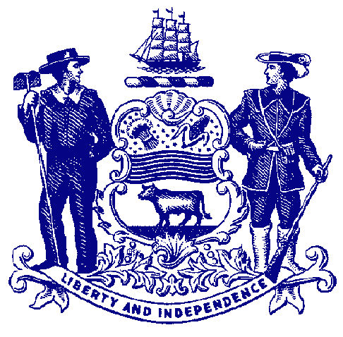

Delaware House of Representatives
Rep. Sherry Dorsey Walker

For Immediate Release:
June 7, 2022

House Passes Dorsey Walker Bill Allowing Residents to Register
to Vote, Cast Ballot on Same Day

HB 25(S) would allow same-day registration for qualified voters
.
DOVER – The House passed legislation Tuesday that would allow same-day voter registration in Delaware, which permits eligible residents to register to vote and cast their ballots on the same day.

Sponsored by Rep. Sherry Dorsey Walker, House Bill 25(S) would eliminate the current deadline to register to vote that is nearly a month before an election. Under the bill, eligible residents could register to vote for presidential primary, state primary, special and/or general elections on the same day they cast their ballots.

“Currently, we have an arbitrary deadline several weeks before an election to register to vote, which disenfranchises potential voters. Upon missing this deadline, they are unable to cast ballots, even if they meet all other eligibility requirements. This is an outdated and unfair practice,” said Rep. Dorsey Walker, D-Wilmington. “Election Day registration has existed in several states for decades and is proven to safely and effectively increase voter turnout. It is time for Delaware to be a leader in our nation, join other states, take this important step toward removing voting barriers and finally enfranchising our constituents.”

Current state law sets the last day to register before an election at the “fourth Saturday prior to the date of the election,” close to a month before Election Day.

Under HB 25(S), a person would need to show a valid and current government-issued photo identification card or current document displaying the name and address of the person registering to vote, such as a utility bill, bank statement, government check, or paycheck.

“Across the country, same-day registration has been demonstrated to increase voter turnout and make certain that no one who should be allowed to vote gets turned away at the polls,” said Sen. Trey Paradee, D-Dover. “I look forward to the swift passage of House Bill 25 in the Senate so that Delaware can join the many states across our nation that allow for same-day registration.”

According to the National Conference of State Legislatures, same-day registration has existed in Maine, Minnesota and Wisconsin since the mid-1970s. Since then, more than 20 states and the District of Columbia have adopted same-day registration, and several other states are contemplating similar laws.

A study of the 2018 elections found that seven of the top 10 states with the highest turnout offered same day voter registration (SDR), which allows voters to register or fix a registration problem when they vote. Voter turnout in states with SDR was seven percentage points higher than states without the option.

HB 25(S) now heads to the Senate for consideration.

###

