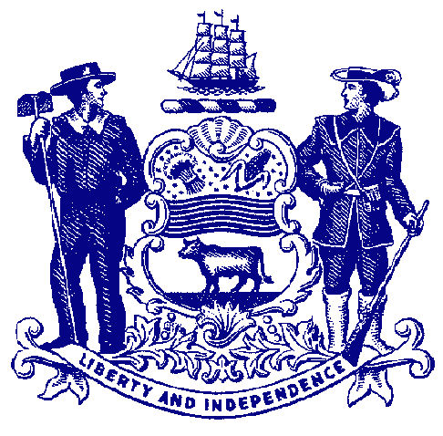

Delaware General Assembly
State of Delaware

For Immediate Release:
May 24, 2022

Joint Finance Committee Approves Raises for State Workers, Retirees

Raises must be voted on by full General Assembly as part of fiscal 2023 budget

DOVER – The legislative budget-writing committee on Tuesday approved raises for state workers that would give many on the lower end of the pay scale a significant boost in pay.

The Joint Finance Committee, 12-member panel of representatives and senators from both parties charged with drafting the state’s operating budget, approved the increases during its first day of markup, a period when the committee takes the governor’s recommended budget and begins voting on specific funding requests, essentially writing the budget.

State employee pay policy is among the first items typically to be voted on. Under the plan approved Tuesday, full-time state workers would receive a raise ranging from 2.3% to 9% depending on their pay grade, with the lowest grades receiving higher raises. Collective bargaining units would receive raises according to whatever they have negotiated. Education employees would receive a 2% raise.

“We owe it to our dedicated state workers – many whom worked through the unprecedented circumstances of the pandemic – to compensate them fairly and offer meaningful opportunities for career advancement. We’re fortunate this year to be able to not only give a good across-the-board raise, but we’re targeting working Delawareans who most need a raise,” said Joint Finance Committee Vice Chair Rep. William Carson. “The cost of goods and services have been increasing rapidly, forcing working families to make tough decisions that no one should have make. By using a sliding scale for raises, we are ensuring all employees receive a raise, but we’re preventing those on the lower end of the pay scale from falling further behind.”

As with many private businesses, state government has experienced significant vacancies, and concerns about hiring and retention have been raised. Whether it’s educators, emergency personnel, social workers, medical staff or first responders, ensuring that these state workers receive a needed pay raise has been a priority. The average state employee salary is less than $49,000 per year and under this plan, they would receive the largest percentage increases, ranging from 5.6% to 9%.

“An investment in our state workforce is an investment in the critical services our communities depend on,” said Sen. Trey Paradee, Chair of the Joint Finance Committee. “Over the winter, nearly every department of state government rang the alarm about their struggles with staff shortages due at least in part to state salaries coming in at below market rate. As we compete for human infrastructure with major corporations in the area, we need to remain competitive if we are going to hope to maintain the level of services our state provides at its current level. The operating budget we are crafting this week is not the final investment in our state workforce that needs to be made, but it is a strong step in the right direction.”

Under the pay policy approved Tuesday, state pensioners would receive a 2-3% increase, depending on date of retirement. Also, all state workers, educators, part-time employees and retirees also would receive a one-time $500 bonus, which is above the governor’s recommended budget.

The Joint Finance Committee will continue reviewing and voting on funding priorities for the fiscal 2023 operating budget this week. Once completed, legislative budget staff will write the final budget bill, which must be approved by the entire General Assembly.

###

