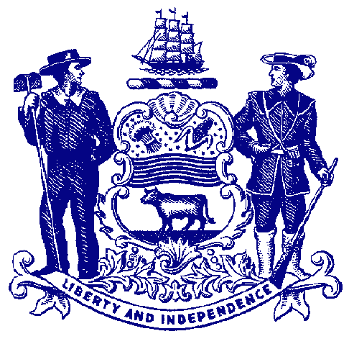

Delaware House of Representatives
Rep. Ed Osienski

For Immediate Release:
April 4, 2022

Lawmakers File Marijuana Legalization, Regulation Measures

HB 371 and 372 would divide Delaware Marijuana Control Act into two separate bills

DOVER – After discussing with colleagues about the best path forward, Rep. Ed Osienski filed bills Thursday designed to legalize and regulate recreational marijuana for adult users.

Previous efforts to pass one bill legalizing adult recreational marijuana and regulating the cultivation, sale and possession of marijuana have fallen short in the House of Representatives, prompting Rep. Osienski as the lead sponsor to explore alternative paths forward.

The decision was to divide the different aspects of the former Delaware Marijuana Control Act (House Bill 305) into two separate bills – one simply legalizing possession of small amounts of marijuana for personal use, and one measure that would regulate the legal industry of growing and selling cannabis.

“In my discussions with colleagues, I learned that some members did not support legalizing marijuana, but they would support the legal framework to regulate and tax marijuana if it was already legal,” said Rep. Osienski, D-Newark/Brookside. “This two-step approach would allow those who have concerns about the act of legalizing marijuana to vote for the regulation aspect, which hopefully will give us the support we need to pass this proposal.”

HB 305 failed in the House earlier this month 23-14, despite winning majority support in the chamber, because bills that deal with taxation and revenue require a three-fifths (3/5) majority, or 25 votes.

House Bill 371 would remove all penalties for possession of one ounce or less of marijuana, except for those who are under 21 years of age. Possession of more than one ounce of marijuana and public consumption remain unclassified misdemeanors.

Because this bill does not have any taxation or revenue aspect to it, the measure would only require a simple majority, or 21 votes in the House. HB 371 has 21 listed House sponsors and co-sponsors.

House Bill 372 would create a legal framework to regulate the cultivation, sale and possession of marijuana, provide opportunities for small businesses to be licensed, and ensure people living in areas disproportionately affected by the prohibition of marijuana have equal access to this new market. The legislation also contains a new framework for directing some of the state proceeds from sales and licensing to justice reform efforts.

HB 372 would regulate and tax marijuana in the same manner as alcohol. It would allow adults 21 and older to purchase up to one ounce of marijuana from a licensed retail marijuana store. Under the bill, the Division of Alcohol and Tobacco Enforcement (DATE) would absorb marijuana enforcement and create a separate, administrative Office of Marijuana Control Commissioner within the Department of Safety and Homeland Security.

The legislation would allow for up to 30 retail licenses to be issued within 16 months of the bill’s effective date. It also would establish a competitive licensing process through the Office of Marijuana Control Commissioner using a scoring system that rewards applicants for paying a living wage, providing employer-paid health insurance, providing sick and paid leave to workers, hiring more full-time workers, focusing on diversity of workforce, and other factors.

HB 372 would establish a marijuana control enforcement fee assessed at point of sale, set at 15%.

The measure would direct 7% of the marijuana tax revenue to a Justice Reinvestment Fund. The proposed fund would be administered by the Department of Justice and would be used to facilitate grants, contracts, services, or initiatives that focus on the following:
- Restorative justice, jail diversion, workforce development, industry-specific technical assistance or mentoring services for economically disadvantaged persons in disproportionately impacted areas.
- Addressing the underlying causes of crime, reducing drug-related arrests, and reducing the prison population in this state.
- Creating or developing technology to assist with the restoration of civil rights and expungement of criminal records.

Because this bill addresses revenue and taxation, it would require a 3/5 vote in each chamber (25 in the House).

HB 372 would create new license pools for Social Equity and Microbusiness applicants. The new Social Equity Applicant pool would be limited to those who either live in a disproportionately affected area, or have either been convicted of a marijuana related offense (barring selling to a minor), or are the child of a person convicted of a marijuana related offense. These applicants would have access to technical assistance programs, reduced fees, an adjusted points scale, and a waiver of the physical location requirement.

The new Microbusiness Applicant pool would be limited to applicants with majority ownership held by Delaware residents. These applicants would have reduced fees, though higher than Social Equity applicants, and an adjusted points scale. These applicants would have access to Cultivation and Product Manufacturing Licenses.

The bill allows municipalities to prohibit the operation of marijuana facilities within their borders through local ordinances that are not in conflict with municipal regulations enacted under this law.

Neither bill would not change existing state law regarding driving under the influence of an illicit or recreational drug. They also would not allow individuals to grow their own plants. Public consumption of marijuana would still not be permitted.

Employer enforcement largely would not change. Employers would be permitted to drug test workers for marijuana to ensure any zero-tolerance policies are being followed. They also would be able to discipline workers for being under the influence at work, as well as prohibit the consumption of marijuana at work.

###

